INSTITUTIONAL PROGRAM REVIEW 2011-12
Program Efficacy

Purpose of Institutional Program Review

Welcome to the Program Efficacy phase of the San Bernardino Valley College Program Review process. Program Review is a systematic process for evaluating programs and services annually. The major goal of the Program Review Committee is to evaluate the effectiveness of programs, (comma not needed here) and to make informed decisions about budget and other campus priorities.

The Institutional Program Review Committee is authorized by the Academic Senate to develop and monitor the college Program Review process, receive unit plans, utilize assessments as needed to evaluate programs, recommend program status to the college president, identify the need for faculty and instructional equipment, and interface with other college committees to ensure institutional priorities are met.

The purpose of Program Review is to:
❑ Provide a full examination of how effectively programs and services are meeting departmental, divisional, and institutional goals
❑ Aid in short-range planning and decision-making
❑ Improve performance, services, and programs
❑ Contribute to long-range planning
❑ Contribute information and recommendations to other college processes, as appropriate
❑ Serve as the campus’ conduit for decision-making by forwarding information to or requesting information from appropriate committees

Our Program Review process is two-fold. It includes an annual campus-wide needs assessment in the fall, (comma not needed here)and an in-depth review of each program every three years that we call the Program Efficacy phase. Instructional programs are evaluated the year after content review, and every three years thereafter, and other programs are placed on a three-year cycle by the appropriate Vice President.

An team of three disinterested committee members will meet with you to carefully review and discuss your document. You will receive detailed feedback regarding the degree to which your program is perceived to meet institutional goals. The rubric that the team will use to evaluate your program is included with this e-mail

When you are writing your program evaluation, you may contact efficacy team assigned to review your department or your division representatives for feedback and input. The list of readers is being sent to you with these forms as a separate attachment.

Completed documents should be sent to, Program Review Co-Chairs and your Division Dean by March 16, 2012. It is the writer’s responsibility to be sure the Committee receives the forms on time.

In response to campus wide feedback that program review be a more interactive process, the committee piloted a new program efficacy process in Spring 2010 that included a review team who will interview and/or tour a program area during the efficacy process. Another campus concern focused on the duplication of information required for campus reports. The efficacy process now incorporates the Educational Master Plan One-Page Summary (EMP Summary) and strives to reduce duplication of information while maintaining a high quality efficacy process.

Program Efficacy, 2011/2012

Complete this cover sheet as the first page of your report.

Program Being Evaluated
Physical Education and Health

Name of Division
Social Science, Human Development and Physical Education

Name of Person Preparing this Report Extension
John Banola 1661

Name of Department Members Consulted
Sue Crebbin, Patricia Rossman, Dawn Adler, Ken Blumenthal, Mike Powell, Pat Meech, Kevin Emerson, Kristin Hauge, Quincy Brewer

Name of Reviewers
Michael Mayne; Paula Ferri-Milligan; Andee Alsip

Work Flow | Due Date | Date Submitted
Date of initial meeting with department
Rough Draft submitted to Program Review Team | 03/07/12
Report submitted to Program Review Team | 03/16/12

Staffing
List the number of full and part-time employees in your area.
Classification | Number Full-Time | Number Part-time, Contract | Number adjunct, short-term, hourly
Managers | 1
Faculty | 10 |  | 6
Classified Staff | 3
Total | 14 |  | 6

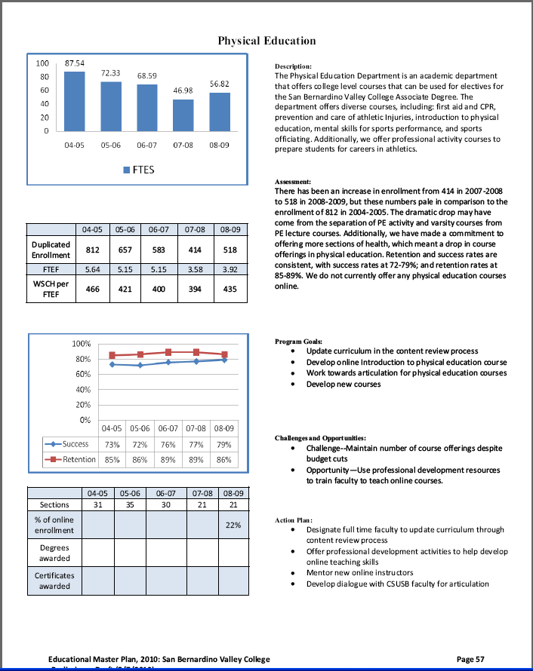

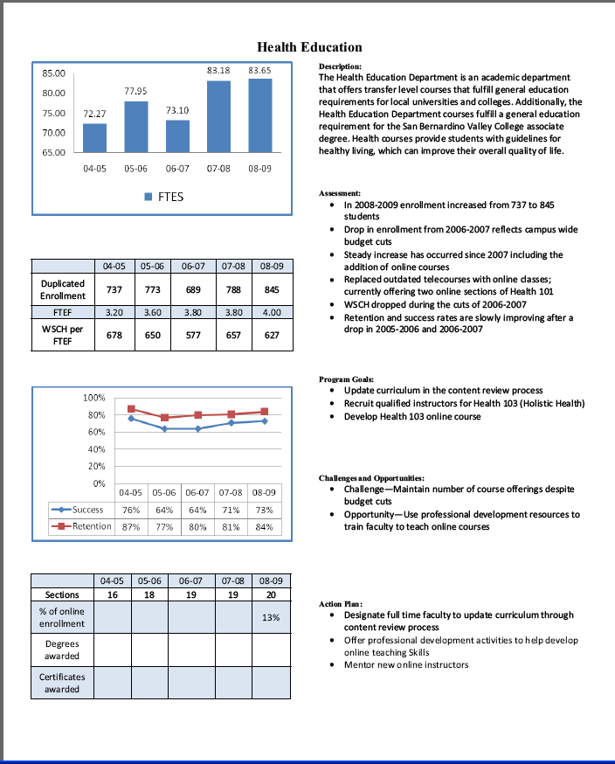

Part I. Questions Related to Strategic Initiative: Access

Use the demographic data provided to describe how well you are providing access to your program by answering the questions below.
Demographic Information
Strategic Initiative | Institutional Expectations
 | Does Not Meet | Meets
Part I: Access
Demographics | The program does not provide an appropriate analysis regarding identified differences in the program’s population compared to that of the general population | The program provides an analysis of the demographic data and provides an interpretation in response to any identified variance.  If warranted, discuss the plans or activities that are in place to recruit and retain underserved populations.
Pattern of Service | The program’s pattern of service is not related to the needs of students. | The program provides evidence that the pattern of service or instruction meets student needs.  If warranted, plans or activities are in place to meet a broader range of needs.

SBVC Student Demographics (3-year Averages)
2008-2011
Gender Campus Pct.  Female 58.5%  Male 41.5%  *Total  *Totals do not include respondents who did not identify gender.  Ethnicity Campus Pct.  Blank 0.47%  Asian 4.58%  Black 19.03%  Filipino 1.93%  Hispanic 49.35%  Nat Amer .99%  Other 1.18%  Pac Islander .75%  White 20.55%  X-undeclared 1.17%  Total 100.00% | Disability Campus Pct.  Non-disabled 96.1%  Disabled 3.9%  Total 100%  Average Age Avg. Age Campus  28.8

PE 2007-2010

Gender
 |  | Frequency | Percent | Valid Percent | Cumulative Percent
Valid |  | 36 | 1.1 | 1.1 | 1.1
 | F | 1402 | 43.2 | 43.2 | 44.3
 | M | 1807 | 55.7 | 55.7 | 100.0
 | Total | 3245 | 100.0 | 100.0

Ethnicity
 |  | Frequency | Percent | Valid Percent | Cumulative Percent
Valid |  | 626 | 19.3 | 19.3 | 19.3
 | A | 58 | 1.8 | 1.8 | 21.1
 | B | 908 | 28.0 | 28.0 | 49.1
 | F | 36 | 1.1 | 1.1 | 50.2
 | H | 984 | 30.3 | 30.3 | 80.5
 | N | 25 | .8 | .8 | 81.3
 | O | 19 | .6 | .6 | 81.8
 | P | 37 | 1.1 | 1.1 | 83.0
 | W | 462 | 14.2 | 14.2 | 97.2
 | X | 90 | 2.8 | 2.8 | 100.0
 | Total | 3245 | 100.0 | 100.0

Disability | Frequency | Dept. Percent | Campus Pct.
No disability | 3076 | 94.8% | 95.5%
Disabled | 169 | 5.2% | 4.5%
Total | 3245 | 100% | 100%

Average Age | N | Youngest | Oldest | Avg. Age Dept. | Avg. Age Campus
 | 3245 | 16 | 65 | 23.02 | 29.1
Health 2007-2010

Gender
 |  | Frequency | Percent | Valid Percent | Cumulative Percent
Valid |  | 58 | 1.0 | 1.0 | 1.0
 | F | 3512 | 62.7 | 62.7 | 63.8
 | M | 2028 | 36.2 | 36.2 | 100.0
 | Total | 5598 | 100.0 | 100.0

Ethnicity
 |  | Frequency | Percent | Valid Percent | Cumulative Percent
Valid |  | 744 | 13.3 | 13.3 | 13.3
 | A | 192 | 3.4 | 3.4 | 16.7
 | B | 1071 | 19.1 | 19.1 | 35.9
 | F | 54 | 1.0 | 1.0 | 36.8
 | H | 2529 | 45.2 | 45.2 | 82.0
 | N | 39 | .7 | .7 | 82.7
 | O | 43 | .8 | .8 | 83.5
 | P | 39 | .7 | .7 | 84.2
 | W | 715 | 12.8 | 12.8 | 96.9
 | X | 172 | 3.1 | 3.1 | 100.0
 | Total | 5598 | 100.0 | 100.0

Disability
Disability | Frequency | Dept. Percent | Campus Pct.
No disability | 5333 | 95.3% | 95.5%
Disabled | 265 | 4.7% | 4.5%
Total | 5598 | 100% | 100%

Age
Average Age | N | Youngest | Oldest | Avg. Age Dept. | Avg. Age Campus
 | 5598 | 15 | 74 | 24.94 | 29.1

PE-I 2007-2010
Gender
 |  | Frequency | Percent | Valid Percent | Cumulative Percent
Valid |  | 10726 | 36.2 | 36.2 | 36.2
 | F | 10273 | 34.6 | 34.6 | 70.8
 | M | 8669 | 29.2 | 29.2 | 100.0
 | Total | 29668 | 100.0 | 100.0

Ethnicity
 |  | Frequency | Percent | Valid Percent | Cumulative Percent
Valid |  | 13404 | 45.2 | 45.2 | 45.2
 | A | 724 | 2.4 | 2.4 | 47.6
 | B | 3560 | 12.0 | 12.0 | 59.6
 | F | 242 | .8 | .8 | 60.4
 | H | 8238 | 27.8 | 27.8 | 88.2
 | N | 127 | .4 | .4 | 88.6
 | O | 151 | .5 | .5 | 89.1
 | P | 133 | .4 | .4 | 89.6
 | W | 2573 | 8.7 | 8.7 | 98.3
 | X | 516 | 1.7 | 1.7 | 100.0
 | Total | 29668 | 100.0 | 100.0

Disability | Frequency | Dept. Percent | Campus Pct.
No disability | 27897 | 94% | 95.5%
Disabled | 1771 | 6% | 4.5%
Total | 29668 | 100% | 100%

Average Age | N | Youngest | Oldest | Avg. Age Dept. | Avg. Age Campus
 | 19141 | 14 | 80 | 25.93 | 29.1
PE-T 2007-2010

Gender
 |  | Frequency | Percent | Valid Percent | Cumulative Percent
Valid | blank | 15 | .5 | .5 | .5
 | F | 970 | 30.3 | 30.3 | 30.8
 | M | 2212 | 69.2 | 69.2 | 100.0
 | Total | 3197 | 100.0 | 100.0

Ethnicity
 |  | Frequency | Percent | Valid Percent | Cumulative Percent
Valid | blank | 674 | 21.1 | 21.1 | 21.1
 | A | 51 | 1.6 | 1.6 | 22.7
 | B | 936 | 29.3 | 29.3 | 52.0
 | F | 12 | .4 | .4 | 52.3
 | H | 1057 | 33.1 | 33.1 | 85.4
 | N | 11 | .3 | .3 | 85.7
 | O | 24 | .8 | .8 | 86.5
 | P | 52 | 1.6 | 1.6 | 88.1
 | W | 307 | 9.6 | 9.6 | 97.7
 | X | 73 | 2.3 | 2.3 | 100.0
 | Total | 3197 | 100.0 | 100.0

Disability | Frequency | Dept. Percent | Campus Pct.
No disability | 3061 | 95.7% | 95.5%
Disabled | 136 | 4.3% | 4.5%
Total | 3197 | 100% | 100%

Does the program population reflect the college’s population? Is this an issue of concern? If not, why not? If so, what steps are you taking to address the issue?

When analyzing the data for comparison purposes, it must be noted that the data provided for Physical Education (PE) and Health was for the years 2007-2010 as opposed to the campus data, which spanned the 2008-2011 years.
When comparing the gender makeup of the campus to the PE department as a whole, the percentage of female students is approximately 15% lower (58.5% to 43.2%) and the percentage of male students is approximately 14% higher (41.5% to 55.7%). The higher proportion of male student-athletes participating in varsity team sports may explain this disparity. The California Community College Athletic Association (http://www.cccaasports.org/gender.asp) demographics show that SBVC gender ratio is reflective of other Community Colleges in the Foothill College and in the State. Additionally, according to the Statistical Abstract of the United States, 2011 campus figures are reflective of National trends in college sports participation and mirror high school sports participation gender demographics. The population of students with disabilities taking courses in PE is slightly higher than the campus (5.2% to 4.5%), which may be due to students participating in the Adapted Physical Education courses offered, as well as student-athletes with disabilities participating on the football and men’s soccer teams. In terms of ethnicity, there appears to be a higher percentage of Black students (+9%) and lower percentages of Asian students (-3.78%), Hispanic students (-19.0%), and White students (-5.35%) when compared to the campus population. These differences may be attributed to the number of students that choose to participate in team sports and/or physical activity courses as part of a healthy lifestyle as opposed to the students who choose to focus strictly on academic courses. Considering that the gender and ethnic make-up of the teams skews the data to a certain extent, it may not be realistic to expect that the student population mirror that of the rest of the campus. However, in an effort to close the gap on these differences, the department will continue to increase awareness about the importance of physical activity/exercise in maintaining a healthy lifestyle, in addition to informing the students of the variety of classes being offered each semester.
When comparing the gender makeup of the campus to the Health courses, the percentage of female students is approximately 5% higher (58.5% to 62.7%) and the percentage of male students is approximately 5% lower (41.5% to 36.2%). While the overall difference is about 5%, the higher percentage of females than males is similar to the campus population and is not a major concern. The percentage of students with disabilities taking health courses is similar to the campus figures. In regards to ethnicity, the percentage of White students is 7.75% lower than the campus percentage. It is not clear what the reason for this disparity is.

Pattern of Service
How does the pattern of service and/or instruction provided by your department serve the needs of the community? Include, as appropriate, hours of operation/pattern of scheduling, alternate delivery methods, weekend instruction/service.

Courses are typically offered in a MW or TTH format, but there are Friday and Saturday courses as well as occasional MWF course offerings. In terms of hours of operation, the courses are offered throughout the day from 8:00A–2:00P as well as in the afternoons/evenings from 4:30P–9:00P. Online Health courses are also offered to students as well. The department feels strongly that the course offerings available to students and the community provides many options and therefore serves needs of our campus population well.

Part II: Questions Related to Strategic Initiative: Student Success
Strategic Initiative | Institutional Expectations
 | Does Not Meet | Meets
Part II: Student Success - Rubric
Data demonstrating achievement of instructional or service success | Program does not provide an adequate analysis of the data provided with respect to relevant program data. | Program provides an analysis of the data which indicates progress on departmental goals.  If applicable, supplemental data is analyzed.
Student Learning Outcomes and/or Student Achievement Outcomes | Program has not completed the first three-year SLO/SAO cycle. | Program has completed the first three-year SLO/SAO cycle. Discusses how SLOs were evaluated and has plans to continue SLO process.

Student Success Data – Physical Education

 |  | 04-05 | 05-06 | 06-07 | 07-08 | 08-09 | 09-10 | 10-11
Sections |  | 31 | 35 | 30 | 21 | 21 | 21 | 24
% of online enrollment
Degrees awarded
Certificates awarded
Data includes: SBVC, SOFF and SBBHS
Student Success Data: Health Education

 |  | 04-05 | 05-06 | 06-07 | 07-08 | 08-09 | 09-10 | 10-11
Sections |  | 16 | 18 | 19 | 19 | 20 | 19 | 19
% of online enrollment |  | 0% | 0% | 0% | 0% | 13% | 21% | 26%
Degrees awarded
Certificates awarded
Data includes: SBVC, SOFF and SBBHS

Provide an analysis of the data and narrative from the program’s EMP Summary and discuss what it reveals about your program.
Data for PE courses shows that there has been a steady increase in student success from 79% in 2008-2009 to 83% in 2010-2011. Additionally, student retention has shown an overall increase of 5% from 86% in 2008-2009 to 91% in 2010-2011.

Student success rates were above the campus average and stable ranging from 73%-74% from 2008-2009 to 2010-2011. Student retention rates, which were above the campus average as well, were stable ranging from 84%-88% from 2008-2009 to 2010-2011. It should be noted that student success and retention rates stayed stable even with the increase in enrollment in the online courses doubling from 13% in 2008-2009 to 26% in 2010-2011.
Supplemental Data
Provide any additional information, such as job market indicators, standards in the field or licensure rates that would help the committee to better understand how your program contributes to the success of your students.
N/A

Student Learning Outcomes and/or Student Achievement Outcomes (See Strategic Initiative 5.1.3)
Has your program completed the initial SLO/SAO three-year cycle? If not, provide a timeline for completion.
Discuss the process used to evaluate SLOs/SAOs and what trends were identified. Describe program plans to continuously review and analyze SLO assessment outcome data to verify SLO progress.

 | Physical Education - COURSES
GE Course | Course | Defined Expected SLO | Defined Assessment of Expected SLO | SLOs Assessed | Data Analyzed | Data used for improvement
 | Course | Defined Expected SLOs | Defined Assessment of Expected SLOs | SLOs assessed | Data Analyzed | Data Used For Improvement
 | HEALTH 101 | X | SP 09 | SP 09 | due 09/09/09
 | HEALTH 103 | X | X
 | PE 200 | X | X
 | PE 201 | X | X
 | PE 210 | X | X
 | PE 222
 | PE 223 | Course Deleted SP 09
 | PE 231 | X | X | SP 09 | due 09/09/09
 | PE 232
 | PE 236 | X | X
 | PE 282 x2 | X | X
 | PE 283 x2 | X | X
 | PE 285 x2 | X | X
 | PE 288 x2 | X | X
 | PE 291 x2 | X | X
 | PE 293 x2 | X | X
 | PE/I 103x4 | X | X
 | PE/I 105x4 | X | X
 | PE/I 108x4 | X | X
 | PE/I 110x4 | Course Deleted FA 09
 | PE/I 115x4 | Course Deleted FA 09
 | PE/I 116x4 | Course Deleted FA 09
 | PE/I 127x4 | X | X | SP 08 | X | Assessment revised SP 09
 | PE/I 132X4 | X | X
 | PE/I 138x4 | X | X | FA 07 | X | Assessment revised SP 09
 | PE/I 148x4 | X | X
 | PE/I 164x4 | X | X
 | PE/I 168x4 | X | X
 | PE/I 173x4 | X | X
 | PE/I 184x4 | X | X
 | PE/I 186x4 | X | X
 | PE/I 188x4 | X | X
 | PE/I 189x4 | X | X
 | PE/I 190x4 | X | X
 | PE/I 192x4 | X | X
 | PE/T 100x4 | X | X
GE Course | Course | Defined Expected SLO | Defined Assessment of Expected SLO | SLOs Assessed | Data Analyzed | Data used for improvement
 | Course | Defined Expected SLOs | Defined Assessment of Expected SLOs | SLOs assessed | Data Analyzed | Data Used For Improvement
 | PE/T 104x4 | X | X | SP 09 | due 09/09/09
 | PE/T 108x4 | X | X | SP 09 | due 09/09/09
 | PE/T 116x4 | X | X | SP 09 | due 09/09/09
 | PE/T 120x4 | X | X
 | PE/T 124x4 | X | X | SP 09 | due 09/09/09
 | PE/T 132x2 | X | X | SP 09 | due 09/09/09
 | PE/V 100 | X | X
 | PE/V 101 | X | X
 | PE/V 102 | X | X
 | PE/V 103 | X | X
GE - ; Total Courses - 45
Sub Totals - 09-10 |  |  |  | 0 | 0
TOTALS |  | 41 | 41 | 9 | 2
Student Learning Outcomes (SLOs) for all courses in PE and Health Education were revised in Spring 2009. Since the last revision was completed 3 years ago, SLOs will need to be re-evaluated shortly. However, considering the issues with the CTA in regards to the whether or not faculty should be compensated for completing/revising SLOs, we are currently in a holding pattern until this matter is resolved.

A number of course SLOs need to be assessed. In order to address assessing these course SLOs, the department co-chairs, dean, and faculty will create a timeline with implementation beginning in fall semester 2012.

Part III. Questions Related to Strategic Initiative: Institutional Effectiveness
Strategic Initiative | Institutional Expectations
 | Does Not Meet | Meets
Part III: Institutional Effectiveness - Rubric
Mission and Purpose | The program does not have a mission, or it does not clearly link with the institutional mission. | The program has a mission, and it links clearly with the institutional mission.
Productivity | The data does not show an acceptable level of productivity for the program, or the issue of productivity is not adequately addressed. | The data shows the program is productive at an acceptable level.
Relevance, Currency, Articulation | The program does not provide evidence that it is relevant, current, and that courses articulate with CSU/UC, if appropriate. | The program provides evidence that the curriculum review process is up to date. Courses are relevant and current to the mission of the program.  Appropriate courses have been articulated or (?) transfer with UC/CSU or plans are in place to articulate appropriate courses.

Mission and Purpose:
SBVC Mission: San Bernardino Valley College provides quality education and services that support a diverse community of learners.
What is the mission statement of the program?
The mission statement for Physical Education and Health is as follows: To facilitate growth and change in the individual through the study and application of human movement principles and participation in physical activities, exercise and sport across the lifespan. This is accomplished by providing excellence in instruction and services through a multidisciplinary approach in: 1) programs at the undergraduate level designed to prepare professionals in human movement, wellness, sport and exercise-related careers; 2) courses that promote general education and interdisciplinary concepts; 3) activity course and programs designed to induce physical, cognitive and affective adaptations; and 4) specialized service programs in life skills. This mission is achieved with the development and maintenance of the behaviors that are essential for a healthy lifestyle.

How does this purpose relate to the college mission?
The department’s mission relates well to the college mission in a number of ways:
- We provide a variety of courses which include both lecture and lab/activity sections to allow more options for students to choose from
- We service students ranging from teenagers to older adults
- We adapt our teaching methodology in order to service students with varying levels of ability (both cognitive and physical) to ensure maximum potential for success
- We offer courses throughout the day and evening to accommodate all different types of schedules so that students have more options to choose from
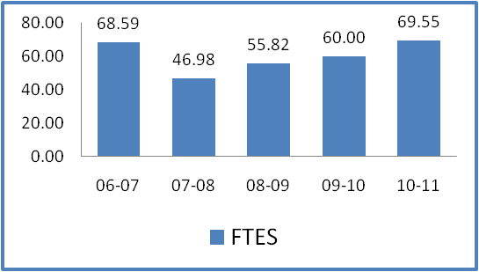
Productivity Data: Physical Education
 | FTES
06-07 | 68.59
07-08 | 46.98
08-09 | 55.82
09-10 | 60.00
10-11 | 69.55
 |  | 04-05 | 05-06 | 06-07 | 07-08 | 08-09 | 09-10 | 10-11
Duplicated Enrollment |  | 812 | 657 | 583 | 414 | 518 | 543 | 614
FTEF |  | 5.64 | 5.15 | 5.15 | 3.58 | 3.92 | 3.72 | 3.93
WSCH per FTEF |  | 466 | 421 | 400 | 394 | 435 | 484 | 531

Productivity Data: Health Education
 | FTES | 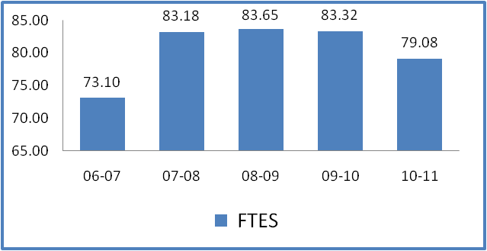
06-07 | 73.10
07-08 | 83.18
08-09 | 83.65
09-10 | 83.32
10-11 | 79.08
 |  | 04-05 | 05-06 | 06-07 | 07-08 | 08-09 | 09-10 | 10-11
Duplicated Enrollment |  | 737 | 773 | 689 | 788 | 845 | 837 | 789
FTEF |  | 3.20 | 3.60 | 3.80 | 3.80 | 4.00 | 3.80 | 3.80
WSCH per FTEF |  | 678 | 650 | 577 | 657 | 627 | 658 | 624

Provide additional analysis and explanation of the productivity data and narrative in the EMP Summary, if needed. Explain any unique aspects of the program that impact productivity data for example; Federal Guidelines, Perkins, number of workstations, licenses etc…
Productivity data for PE shows that FTES has increased significantly (+48%) from 46.98 in 2007-2008 to 69.55% in 2010-2011. Duplicated enrollment increased by 48% from 414 in 2007-2008 to 614 in 2010-2011. Additionally, FTEF has increased 9.77% from 3.58 in 2007-2008 to 3.93% in 2010-2011. Lastly, WSCH per FTEF has also increased significantly (+34.77%) from 394 in 2007-2008 to 531 in 2010-2011.
Productivity data for Health Education shows a small (-4.93%) decrease in FTES from 83.18 in 2007-2008 to 79.08 in 2010-2011. This decrease may be due to budget cuts resulting in lower enrollment caps with the same number of sections being offered. Duplicated enrollment showed higher numbers from 2008-2009 to 2009-2010, but in 2010-2011 returned to near 2007-2008 numbers at 789. Again, this may be due to fewer course sections being offered. Between 2007-2008 and 2010-2011, FTEF remained stable at 3.80 for every year except for 2008-2009, which peaked at 4.00. WSCH per FTEF has decreased from 657 in 2007-2008 to 624 in 2010-2011. This is still above the campus average however. As mentioned previously, this decrease may be attributable to a decrease in cap size with the same number of course offerings.

Relevance and Currency, Articulation of Curriculum
Social Sciences, Human Development & Physical Education
Physical Education
 | Course | Status | Last Content Review | Next Review Date
 | PE098 Physical Education Work Experience | Active | 12/07/2009 | 12/07/2015
 | PE/V100 PE/V-100 | Active | 04/19/1993 | 04/19/1999
 | PE/T100X4 Team Sports Activities: Baseball | Active | 11/28/2011 | 11/28/2017
 | PE/V101 PE/V-101 | Active | 04/19/1993 | 04/19/1999
 | PE/V102 PE/V-102 | Active | 04/19/1993 | 04/19/1999
 | PE/V103 PE/V-103 | Active | 04/19/1993 | 04/19/1999
 | PE/I103X4 Badminton | Active | 08/29/2011 | 08/29/2017
 | PE/T104X4 Team Sport Activities: Basketball | Active | 10/17/2011 | 10/17/2017
 | PE/I105X4 PE/I-105X4 Low Impact Aerobics | Active | 04/14/2005 | 04/14/2011
 | PE/T108X4 Team Sport Activities: Football | Active | 11/15/2004 | 11/15/2010
 | PE/I108X4 PE/I 108X4 Weight Training | Active | 11/15/2004 | 11/15/2010
 | PE/I112X4 Body Conditioning | Active | 11/14/2011 | 11/14/2017
 | PE/T116X4 Team Sports Activities: Soccer | Active | 04/04/2011 | 04/04/2017
 | PE/T120X4 Team Sport Activities: Softball | Active | 08/29/2011 | 08/29/2017
 | PE/T124X4 Team Sport Activities: Volleyball | Active | 10/03/2011 | 10/03/2017
 | PE/I127X4 Walking for Fitness | Active | 11/14/2011 | 11/14/2017
 | PE/T132X2 Team Sports Activities: Advanced Volleyball | Active | 11/28/2011 | 11/28/2017
 | PE/I138X4 Physical Fitness | Active | 03/14/2011 | 03/14/2017
 | PE/I148X4 Tennis | Active | 10/14/2004 | 10/14/2010
 | PE/I164X4 Swimming | Active | 08/29/2011 | 08/29/2017
 | PE/I168X4 Yoga | Active | 10/14/2004 | 10/14/2010
 | PE/I173X4 Water Aerobics | Active | 10/14/2004 | 10/14/2010
 | PE/I184X4 Adapted Physical Education: Swimming | Active | 08/29/2011 | 08/29/2017
 | PE/I186X4 Adapted Physical Education: Stretching and Stress Reduction | Active | 10/17/2011 | 10/17/2017
 | PE/I188X4 Adapted Physical Education: Fitness and Conditioning | Active | 08/29/2011 | 08/29/2017
 | PE/I189X4 Adapted Physical Education: Resistance Training | Active | 11/14/2011 | 11/14/2017
 | PE/I190X4 Tai Chi | Active | 11/14/2011 | 11/14/2017
 | PE200 Intro to PE and Kinesiology | Active | 11/15/2003 | 11/15/2009
 | PE201 Mental Skills for Sport Performance | Active | 11/15/2003 | 11/15/2009
 | PE210 Sports Officiating | Active | 10/17/2011 | 10/17/2017
 | PE222 Independent Study in Physical Education | Active | 11/15/2011 | 11/15/2017
 | PE231 First Aid and CPR | Active | 02/28/2011 | 02/28/2017
 | PE232 Prevention and Care of Athletic Injuries | Active | 11/15/2003 | 11/15/2009
 | PE236 Stress Management and Wellness | Active | 11/15/2003 | 11/15/2009
 | PE282X2 Professional Actvts: Baseball | Active | 11/15/2004 | 11/15/2010
 | PE283X2 Professional Actvts: Basketbal | Active | 11/15/2004 | 11/15/2010
 | PE285X2 Professional Actvts: Football | Active | 11/15/2004 | 11/15/2010
 | PE288X2 Professional Actvts: Softball | Active | 11/15/2004 | 11/15/2010
 | PE291X2 Professional Activities: Track and Field | Active | 11/15/2004 | 11/15/2010
 | PE293X2 Professionl Actvts: Volleyball | Active | 11/15/2004 | 11/15/2010
 | PE/V100 PE/V-100 | Pending | 04/19/1993 | 04/19/1999
 | PE/V101 PE/V-101 | Pending | 04/19/1993 | 04/19/1999
 | PE/T108X4 Team Sports Activities: Football | Pending | 11/15/2004 | 11/15/2010
 | PE/I108X4 PE/I 108X4 Weight Training | Pending | 11/15/2004 | 11/15/2010
 | PE/I108x4 Weight Training | Pending | 11/15/2004 | 11/15/2010
 | PE/V110X3 Intercollegiate Cross Country - Men | Pending | 11/15/2005 | 11/15/2011
 | PE/V111X3 Intercollegiate Cross Country - Women | Pending | 11/15/2005 | 11/15/2011
 | PE/V113X3 Intercollegiate Soccer - Men | Pending | 11/15/2005 | 11/15/2011
 | PE/V114X3 Intercollegiate Soccer - Women | Pending | 11/15/2005 | 11/15/2011
 | PE/V115X3 Intercollegiate Volleyball - Women | Pending | 11/15/2005 | 11/15/2011
 | PE/V120X3 Intercollegiate Basketball - Men, Fall | Pending | 11/15/2005 | 11/15/2011
 | PE/V122x3 Intercollegiate Basketball - Women, Fall | Pending | 04/19/1993 | 04/19/1999
 | PE/V123X3 Intercollegiate Basketball -Women, Spring | Pending | 11/15/2005 | 11/15/2011
 | PE/V130X3 Intercollegiate Baseball | Pending | 11/15/2005 | 11/15/2011
 | PE/V131X3 Intercollegiate Softball | Pending | 11/15/2005 | 11/15/2011
 | PE/V132X3 Intercollegiate Track and Field - Men | Pending | 11/15/2005 | 11/15/2011
 | PE/V133X3 Intercollegiate Track and Field - Women | Pending | 11/15/2005 | 11/15/2011
 | PE/I148X4 Tennis | Pending | 10/14/2004 | 10/14/2010
 | PE/I173X4 Water Aerobics | Pending | 10/14/2004 | 10/14/2010
 | PE/I190x4 Tai Chi | Pending | 11/15/2004 | 11/15/2010
 | PE/I192x4 Karate: Chinese Kenpo | Pending | 11/15/2005 | 11/15/2011
 | PE200 Intro to PE and Kinesiology | Pending | 11/15/2003 | 11/15/2009
 | PE201 Mental Skills for Sport Performance | Pending | 11/15/2003 | 11/15/2009
 | PE238 Exercise Theory, Testing and Prescription | Pending | 04/15/2000 | 04/15/2006
 | PE283X2 Professional Actvts: Basketbal | Pending | 11/15/2004 | 11/15/2010
 | PE288X2 Professional Activities: Softball | Pending | 11/15/2004 | 11/15/2010
 | PE291X2 Professional Activities: Track and Field | Pending | 11/15/2004 | 11/15/2010
 | PE293X2 Professionl Actvts: Volleyball | Pending | 11/15/2004 | 11/15/2010
 | PE/I132x4 Distance Running | Launched | 08/29/2011 | 08/29/2017
 | PE/I168x4 Yoga | Launched | 08/29/2011 | 08/29/2017
 | PE232 Prevention and Care of Athletic Injuries | Launched | 11/15/2003 | 11/15/2009
 | PE/T100X4 Team Sport Activities: Baseball | Historical
 | PE/I103X4 PE/I 103X4 Badminton | Historical
 | PE/T104X4 Team Sport Activities: Basketball | Historical
 | PE/I110X4 Foil Fencing | Historical
 | PE/I110X4 Foil Fencing | Historical
 | PE/I115X4 Epee and Saber Fencing | Historical
 | PE/T116X4 Team Sport Activities: Soccer | Historical
 | PE/I116X4 PE/I-116X4 Epee Fencing | Historical
 | PE/T120X4 Team Sport Activities: Softball | Historical
 | PE/T124X4 Team Sport Activities: Volleyball | Historical
 | PE/I127X4 Walking for Fitness | Historical
 | PE/T132X2 Team Sport Activities: Advanced Volleyball | Historical
 | PE/I138X4 Physical Fitness | Historical
 | PE/I143X4 Water Polo | Historical
 | PE/I144X4 Racquetball | Historical
 | PE/I164X4 PE/I-164X4 Swimming | Historical
 | PE/I184X4 Adapted Physical Education - Swimming | Historical
 | PE/I186X4 Adapted Physical Education - Stretching and Stress Reduction | Historical
 | PE/I188X4 PE/I-188X4 | Historical
 | PE/I189X4 PE/I-189X4 | Historical
 | PE/I190X4 PE/I-190X4 Tai Chi | Historical
 | PE210 Sports Officiating | Historical
 | PE222 Independent Study in P.E. | Historical
 | PE223 Lifeguard Training | Historical
 | PE231 First Aid and CPR | Historical
Social Sciences, Human Development & Physical Education
Health Education
 | Course | Status | Last Content Review | Next Review Date
 | HEALTH101 Health Education | Active | 12/10/2007 | 12/10/2013
 | HEALTH103 Introduction to Holistic Health | Active | 04/15/2004 | 04/15/2010
 | HEALTH101 Health Education | Pending | 12/10/2007 | 12/10/2013
 | HEALTH103 Introduction to Holistic Health | Pending | 04/15/2004 | 04/15/2010

If applicable to your area, describe your curriculum by answering the following questions.
The Content Review Summary from Curricunet indicates the program’s current curriculum status. If curriculum is out of date, explain the circumstances surrounding the error and plans to remedy the discrepancy.
Until recently, the department has not been efficient in keeping the courses up-to-date. A lot of progress has been made more recently in terms of updating curriculum. However, there are still a number of courses that need to be addressed.
Courses that have been updated recently include the following:
- PE/T 100, 104, 116, 120, 124, 132
- PE/I 103, 112, 127, 138, 168, 184, 186, 188, 189, 190
- PE 210, 222, 231
For the courses that are listed as past their review date, please see below for plans to address the situation:
- PE/I 105: Course will be updated and launched by end of fall semester 2012
- PE/I 108: Course has been updated and will be launched by end of spring semester 2012
- PE/I 148: Course has been submitted for deletion
- PE/I 168: Course has been updated, launched, and approved
- PE/I 173: Course has been submitted for deletion
- PE/I 192: Faculty discussion will take place in spring semester 2012 in regards to keeping or deleting course. If the decision is made to keep the course, it will be updated and launched by end of fall semester 2012.
- PE 200: Course has been updated and is currently in the CurricUNET queue
- PE 201: Course has been updated and is currently in the CurricUNET queue
- PE 232: Course has been updated and is currently in the CurricUNET queue
- PE 236: Faculty discussion will take place in spring semester 2012 in regards to keeping or deleting course. If the decision is made to keep the course, it will be updated and launched by end of fall semester 2012.
- PE 238: Course was deleted in November 2003
- PE/V: There are ongoing discussions in regards to what should be done with this series of courses. Discussions will continue throughout the spring 2012 semester with the intent of making final decisions by the end of the semester. Changes, deletions, or updates will be take place by the end of the fall semester 2012
- PE – Professional Activities: There are ongoing discussions in regards to what should be done with this series of courses. Discussions will continue throughout the spring 2012 semester with the intent of making final decisions by the end of the semester. Changes, deletions, or updates will be take place by the end of the fall semester 2012
Articulation and Transfer
List Courses above 100 where articulation or transfer is not occurring | With CSU | With UC
Health 103 – Introduction to Holistic Health | Articulates | Does Not Articulate
PE 236 – Stress Management and Wellness | Articulates | Does Not Articulate
PE/V – Intercollegiate Sports Activities | Does Not Articulate | Does Not Articulate

Describe your plans to make course qualify for articulation or transfer.
Information will be obtained to determine what is needed for Health 103 and PE 236 to articulate with the UC system. Discussions are ongoing between department faculty and the articulation officer to make the necessary changes to the PE/V courses in order to submit in fall semester 2012 for approval for the 2014 catalog.

Currency
Follow the link below and review the last college catalog data.
http://www.valleycollege.edu/academic-career-programs/college-catalog.aspx
Is the information given accurate? Which courses are no longer being offered? (Include Course # and Title of the Course). If not, how does the program plan to remedy the discrepancy?
The information presented in the 2011-2012 college catalog is current with the exception of the following:
- PE/I 148x4 Tennis is no longer being offered
- PE/I 164x4 Swimming is no longer being offered
- PE/I 173x4 Water Aerobics is no longer being offered
- PE/I 184x4 Adapted Physical Education: Swimming is no longer being offered.
All aforementioned courses have been submitted to CurricUNET for deletion. These courses will also be submitted to the instruction office for deletion from the catalog.
Part IV. Planning
Strategic Initiative | Institutional Expectations
 | Does Not Meet | Meets
Part IV: Planning - Rubric
Trends | The program does not identify major trends, or the plans are not supported by the data and information provided. | The program identifies and describes major trends in the field. Program addresses how trends will affect enrollment and planning. Provide data or research from the field for support.
Accomplishments | The program does not incorporate accomplishments and strengths into planning. | The program incorporates substantial accomplishments and strengths into planning.
Challenges | The program does not incorporate weaknesses and challenges into planning. | The program incorporates weaknesses and challenges into planning.

What are the trends, in the field or discipline, impacting your student enrollment/service utilization? How will these trends impact program planning?
Changes in the repeatability of courses across the board may affect enrollment negatively. Courses will no longer be “X4”, with a combination of all ability levels taking the same course. Instead, courses will be separated into different levels according to ability. This will result in students needing to register separately for either the beginning, intermediate, or advanced course, which may result in sections not being filled. In addition, starting in summer 2012, students are only allowed 3 attempts at completing a course. After the third attempt, students will no longer be allowed to take the course. Some students and community members who take our activity courses do so in order to maintain a healthy lifestyle. Once this change in repeatability takes place, the number of activity courses available to them will be diminished. To address these issues, the department will explore adding curriculum (i.e. walking for seniors, fitness for life, etc.) that will allow more community members to participate. The department will also work with the district in exploring how to create more curriculum for community members to participate in.
One of the emerging trends is the increased focus on living healthier, more active lifestyles. The Healthy People 2020 (HP 2020) campaign is one of the driving forces behind getting our population more active. Specifically in regards to physical activity, the goal of HP 2020 is to “Improve health, fitness, and quality of life through daily physical activity.” In addition, one of the objectives in regards to physical activity is to “Reduce the proportion of adults who engage in no leisure-time physical activity.” Utilizing HP 2020, our department can develop courses to provide opportunities for our students and community members to reach this goal and objective. As we continue to update our curriculum, a department sub-committee will monitor what courses other community colleges are offering. As the sub-committee determines which courses we can offer (considering the facilities/equipment we currently have), curriculum will be developed as allowed by budget constraints to better service our students.
Depending on a number of factors, such as budget and enrollment numbers, these trends may affect program planning in terms of limiting and/or expanding the variety of courses we can offer and the number of sections for each course as well. The department will monitor the enrollment trends from previous semesters to determine if/when we can expand our course offerings to better service our students.
Accomplishments and Strengths
Referencing the narratives in the EMP Summary, provide any additional data or new information regarding the accomplishments of the program, if applicable. In what way does your planning address accomplishments and strengths in the program?
One of the department’s accomplishments is that the majority of the courses offered in the department now articulate with both the UC and CSU systems. The department will make the necessary changes to the remaining courses that currently do not articulate in order to make sure they will articulate with the UC and CSU systems.

The department has also seen a steady increase in the number of students registering for the online health courses. To continue this trend, the department will explore the possibility of developing more online courses such as Health 103, PE 200, and PE 236.

Another accomplishment is that the department has secured funding for ordering new weight training and cardiovascular fitness equipment in spring 2012. This ties in nicely with a major strength of our program, which is the dynamic full-time and part-time faculty members who possess the skill set to teach a wide variety of courses. Knowing that our faculty has the skills to teach a variety of topics/activity courses and that we will be acquiring new equipment will allow us to plan for and develop new curriculum, such as spinning or cross-fit type classes, to better serve our current and future student population.

Another major strength of our department is the adapted physical education curriculum. Although four courses were offered previously, the loss of the swimming pool only allows the department to currently offers three courses PE/I 186, 188, and 189. Data from the four courses offered in the 09/10 academic year shows an overall average retention rate of 88.5%, as well as 89% and 100% success rates based on census and final enrollment numbers respectively. To increase course offerings and further strengthen the adapted program, the department will explore adding new adapted PE curriculum such as adapted tai chi.

Challenges
Referencing the narratives in the EMP Summary, provide any additional data or new information regarding planning for the program. In what way does your planning address trends and weaknesses in the program?
One of the challenges the department faces is updating the curriculum. Great progress has been made, but there are still a number of courses that need to be updated. Some of the issues related to this challenge are 1) articulation, 2) repeatability and 3) leveling of courses. This challenge has been addressed through the assigning of a specific faculty member to lead the update process until all courses are current and submitted to CurricUNET by the end of fall semester 2012. Another challenge is the fact that not all faculty in the department are currently trained to teach online courses. With the steady increase in the number of students registering for online courses, as well as the potential development of new online courses, more faculty will need to be trained to teach online. This will be addressed by utilizing SBVC’s professional development resources in order to train all department faculty members to teach online. The department will also encourage faculty to participate in the April 3, 2012 flex day activities, as well as the fall semester professional development opportunities.

V. Questions Related to Strategic Initiative: Technology, Campus Climate and Partnerships.
Part V: Technology, Partnerships & Campus Climate
 | Program does not demonstrate that it incorporates the strategic initiatives of Technology, Partnerships or Campus Climate.  Program does not have plans to implement the strategic initiatives of Technology, Partnerships or Campus Climate | Program demonstrates that it incorporates the strategic initiatives of Technology, Partnerships and/or Campus Climate.  Program has plans to further implement the strategic initiatives of Technology, Partnerships and/or Campus Climate.

Describe how your program has addressed the strategic initiatives of technology, campus climate and/or partnerships. What plans does your program have to further implement these initiatives.
Technology:
Our department has increased the number of sections of online health courses offered to meet the demands of increased enrollment. Our department will utilize professional development resources to train more faculty to teach online so that as enrollment and the number of sections offered rises, there will be qualified faculty available to teach. Our department utilizes Blackboard to maintain open communication with students enrolled in our courses.
Partnerships:
Our department consistently has students from the middle college program enrolled in our physical activity courses. We have guest lecturers from student health services to help educate our students in topics such as nutrition and blood pressure. We will develop more partnerships with campus clubs, health services, and community entities to better serve our student’s needs. Once the new physical education/athletics facility is completed, new partnerships will be sought out for various events, including facility rental for conferences and high school events, etc.
Campus Climate:
Our department is in the process of developing a new facility that is scheduled to be completed in 2016. The new facility will house a contemporary fitness center, new basketball and volleyball courts, and rooms for lectures and group fitness courses. This facility will give our department the ability to serve students in a safer environment that will be more conducive to the activity and/or lecture for that class session. In addition, with the new facility we plan to develop curriculum specific to all the different spaces that will be available for teaching. Lastly, the new facility will allow for more opportunities to work cooperatively with other campus entities which will further the sense of a true campus community.

